Knights of Columbus Patapsco Council #1960
Hoolapendence Day Celebration!
Featuring The Hooligans!
A band of Maryland Renaissance Festival fame playing: traditional Irish, original, and classic rock tunes. Also featuring…
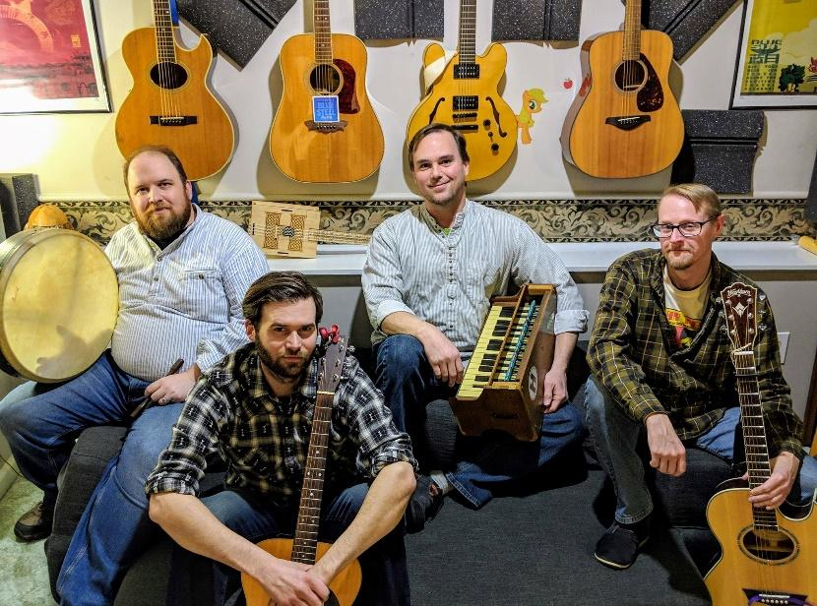
Bagpiper! Raffles! Irish-themed buffet!

Saturday, July 10th, 2021, 7–11 pm at 1010 Frederick Rd., Catonsville, MD.
Ticket Price $40. Advance sales only. Get your tickets before they sell out!
PLEASE NOTE: Tickets are limited due to safety limits and precautions.
Price includes Irish-themed buffet. Cash bar including Irish favorites. And we mean cash.
For more information…
Visit the Facebook pages of The Hooligans or Knights of Columbus Patapsco Council No. 1960
Buy tickets online at www.kofc1960.org or via the PayPal link at the Facebook pages above.
Contact the event organizer, Joseph Melchor, at teacherman68@hotmail.com with any questions.
Proceeds benefit Council charities and activities.

