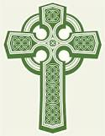
St. Patrick’s Day Celebration! Featuring Cormorant’s Fancy!
Knights of Columbus Patapsco Council #1960
Cormorant’s Fancy is a much-celebrated band that delivers brazenly traditional music of Ireland, Scotland, and the Celtic Nations. Check them out on Spotify & YouTube.
Cormorant’s Fancy will be joined by Ezra & Joseph Melchor performing traditional Celtic sets on the bagpipes & bodhran. AND BY traditional Irish step-dancers.
Saturday, March 14th, 2026, 7–11 P.M., Beaumont Hall, 1010 Frederick Rd., Catonsville, MD. Doors open at 6:30 P.M.
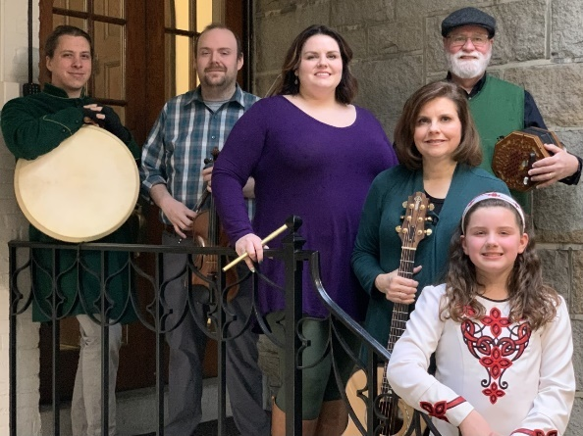
- Reserve your spots at www.kofc1960.org. Early bird tickets $35. Starting March 1st, prices rise to $40, so reserve your spots early. This is a family-friendly event. Children 12 & under are $12. Babes-in-arms are free. Contact the organizer directly for children’s admission. (See below for contact information.)
- Price of ticket includes Irish-themed buffet & dessert, soft drinks, and water.
- Cash bar including many Irish favorites at very reasonable prices.
- 50/50 raffles and prizes. Please bring cash for these.
For more information, visit the Facebook pages of Cormorant’s Fancy or Knights of Columbus Patapsco Council No. 1960, or contact the event organizer, Joseph Melchor, at teacherman68@hotmail.com.
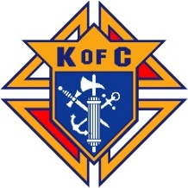
Knights of Columbus is a charitable non-profit. Proceeds to benefit Women’s Center West and the charitable works of the Knights of Columbus.

